**ECSE 428 – Software Engineering Practice**

**Assignment B: Test Driven Development**

**Winter 2014**

Dao, Nhat-Quang 260457711

Singzon, Ryan 260397455

Contents

Domain Logic Tests: 2

1. The layout contains any number of elements 2

2. Three input fields exist 3

3. Submit button exists 4

4. Each input field must be filled 5

# Domain Logic Tests:

## The layout contains any number of elements

Setup: None

Expected Result: The layout should have elements in which the user can input their specifications.

Failing Screenshot:

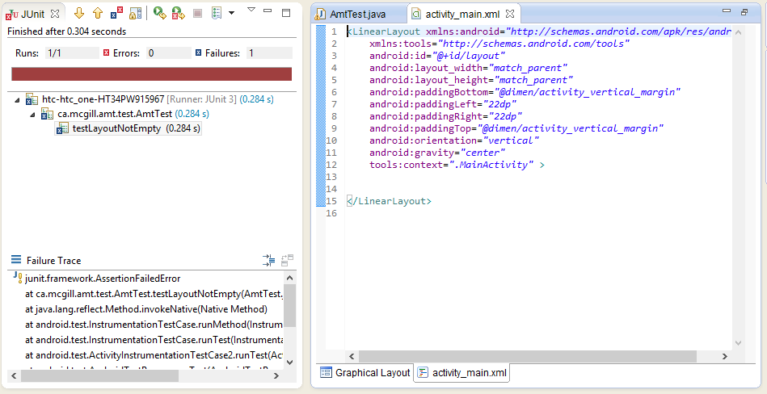

Passing Screenshot

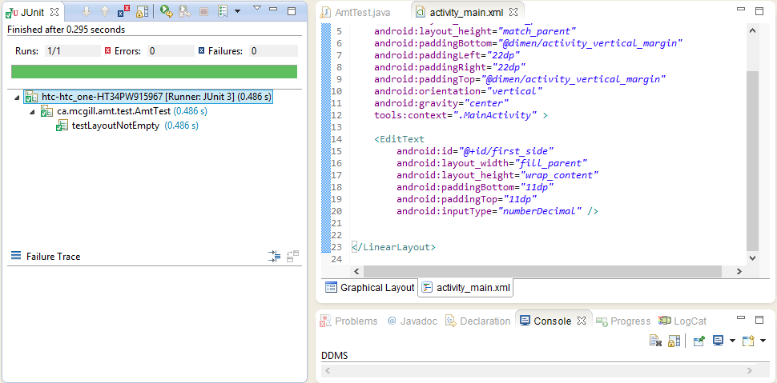

## Three input fields exist

Setup: None

Expected result: The layout should contain three input fields, one for each side of the triangle

Failing Screenshot:

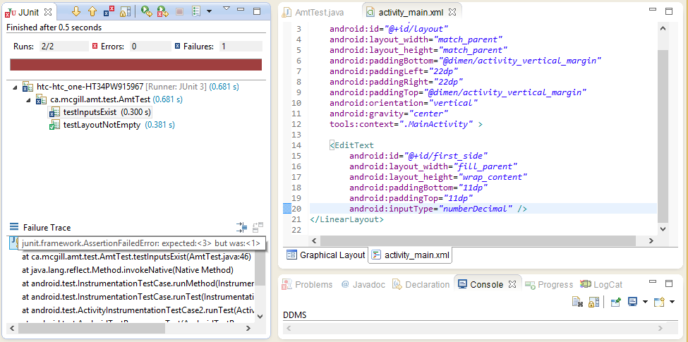

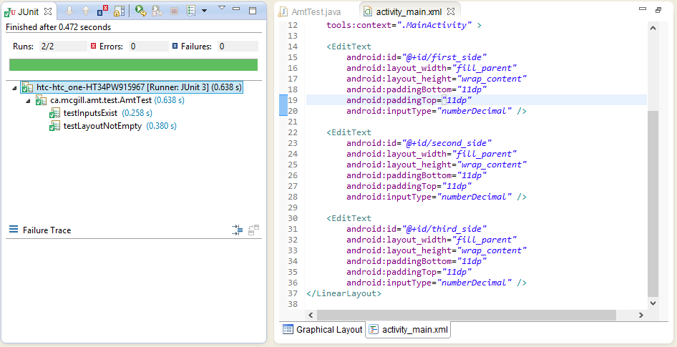 Passing screenshot:

## Submit button exists

Setup: None

Expected result: The activity should display a button that a user presses to obtain a result for their input

Failing screenshot:

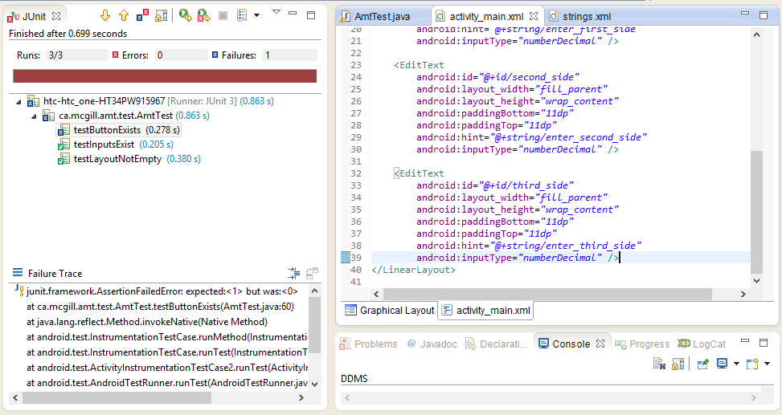

Passing screenshot:

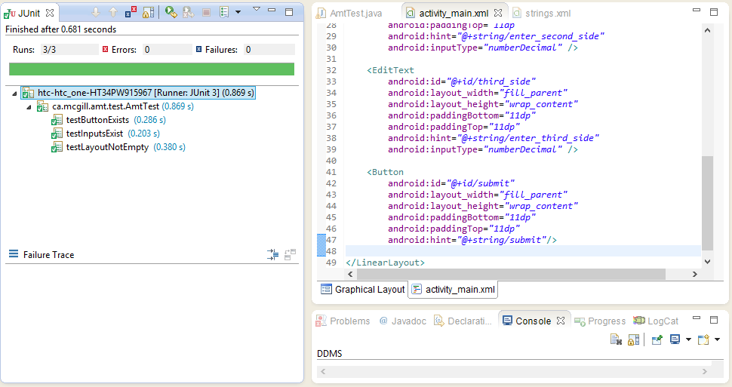

# User Error Tests

## None of the inputs are filled

Setup: Each input is left blank, then the submit button is pressed

Expected result: An error message appears telling the user that all inputs must be filled

Failing screenshot:

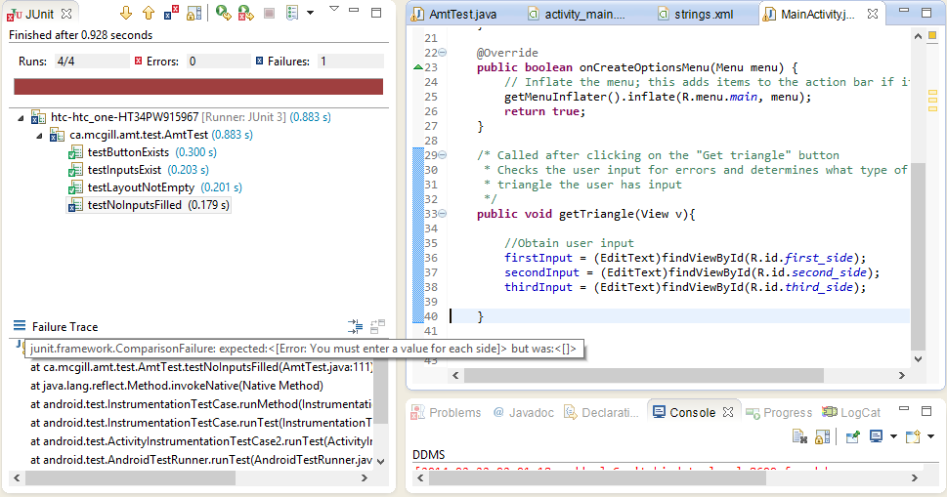

Passing Screenshot:

